**NANDHA ENGINEERING COLLEGE**

(An Autonomous Institution, Affiliated to Anna University, Chennai)

# ERODE–638052



## A Project Report

***Submitted by***

THARIKAA L S (23AI060)

*In partial fulfillment for the award of the degree*

*of*

# BACHELOR OF TECHNOLOGY

# IN

# ARTIFICIAL INTELLIGENCE AND DATA SCIENCE

**DEPARTMENT OF ARTIFICIAL INTELLIGENCE AND**

**DATA SCIENCE**

What is Tableau?

Tableau is a powerful and easy-to-use data visualization tool that helps people understand data.  
It allows users to create beautiful charts, dashboards, and reports without needing to write complex code.  
With Tableau, we can turn raw data into clear, interactive visual stories to find trends, patterns, and insights.  
It is widely used in businesses, research, and education to make better decisions by seeing data visually.

Project: Car Sales Analysis

In this project, we are using Tableau to study and understand car sales data.  
The main aim is to turn the raw car sales information into beautiful and interactive dashboards that show:

* Total cars sold each month
* Sales by car brand
* Sales by region or city
* Top-selling car models
* Trends in car sales over time

Steps in the Project:

1. Connect Tableau to the car sales data (from an Excel file or database).
2. Clean the data if needed (remove errors or missing values).
3. Create visualizations like bar charts, pie charts, line graphs, and maps.
4. Build dashboards that combine different charts together.
5. Analyze the dashboards to find patterns, trends, and useful insights.

Importance of This Project:

* Helps car companies understand which cars are selling the most.
* Identifies the best regions for car sales.
* Shows sales trends across different months and years.
* Supports better business planning and marketing strategies.

## YTD Sales Weekly Trend:

## What This Chart Shows:

## This line chart illustrates the weekly trend of Year-To-Date (YTD) sales, showing how total sales accumulate and change week by week over the course of the year.

## The X-axis represents the weeks of the year (Week 1, Week 2, etc.), and the Y-axis shows the total sales amount up to that week.

## The line shows how sales have increased or decreased over time, helping us understand sales growth patterns and trends.

## How We Built It:

## X-Axis (Weeks): The X-axis represents the weeks of the year (for example, Week 1 to Week 52), showing the flow of sales across different weeks.

## Y-Axis (YTD Sales Amount): The Y-axis shows the cumulative total sales (in USD or any currency of choice) up to each specific week. As the weeks progress, the total sales keep accumulating, and the line moves upward as more sales are made.

## YTD Total Sales by Body Style:

## What This Chart Shows:

## This pie chart visualizes how Year-To-Date (YTD) total sales are distributed across different car body styles (e.g., Sedan, SUV, Truck, Coupe).

## Each slice of the pie represents the percentage of the total YTD sales that come from a specific body style.

## The chart makes it easy to compare how much each body style contributes to the overall sales.

## How We Built It:

## Slices (Body Styles): Each slice in the pie represents a different car body style such as Sedan, SUV, Truck, etc.

## Size (Angle of Slice): The size of each slice is proportional to the YTD sales for that body style. The larger the slice, the greater the sales contribution from that body style.

YTD Total Sales by Color :

What This Chart Shows:

* The donut chart displays the distribution of Year-To-Date (YTD) total sales across different car colors.
* Each slice represents a specific car color (e.g., Red, Blue, Black, White).
* The size of each slice corresponds to the sales volume for that color. Larger slices indicate higher sales for that color.
* This visualization provides a simple way to understand which car colors are most popular based on their sales.

How We Built It:

* Slices:  
  Each slice represents a car color (e.g., Red, Blue, Black, White).
* Size of Slice:  
  The size of each slice is determined by the total YTD sales for that specific color.
* Color Scheme:  
  Each car color is represented by a distinct color in the chart, making it easy to identify each slice (e.g., Red for Red cars).

YTD Cars Sold by Dealer Region :

What This Chart Shows:

This bar chart visualizes the distribution of Year-To-Date (YTD) car sales based on different dealer regions (e.g., North, South, East, West). Each bar represents the number of cars sold in a specific region. The length of each bar indicates the sales volume in that region, with longer bars representing higher sales. This chart allows for an easy comparison of how each dealer region contributes to the overall YTD sales.

How We Built It:

* Bars (Dealer Regions):  
  Each bar represents a different dealer region such as North, South, East, West, etc.
* Size (Length of Bar):  
  The length of each bar corresponds to the total YTD sales in that region. Longer bars represent higher sales.
* Color Scheme:  
  Each bar can be assigned a distinct color for easy identification of regions (e.g., blue for North, red for South).

Company-Wise Sales Trend in Grid Form :

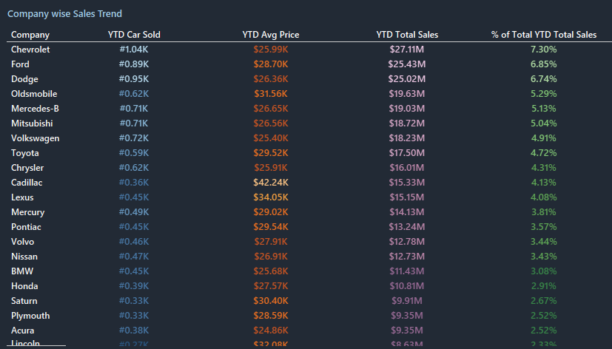

What This Grid Shows:

This tabular grid displays the Year-To-Date (YTD) sales figures for each car company. Each row represents a different company, showing the company's name and its corresponding YTD total sales. The grid offers a clear, organized view, making it easy to compare how different companies are performing based on their total sales. It helps users quickly understand which companies are leading in sales and which ones are behind.

How We Built It:

* Rows (Companies):  
  Each row lists a different car company (e.g., Toyota, Ford, BMW, Tesla).
* Columns:  
  The grid contains two main columns:
  1. Company Name – showing the name of the car company.
  2. YTD Sales – showing the total number of cars sold by that company up to the current date.
* Sorting:  
  The grid can be sorted based on YTD sales, either in ascending or descending order, allowing users to view top-selling or low-selling companies easily.

CAR SALES DASHBOARD

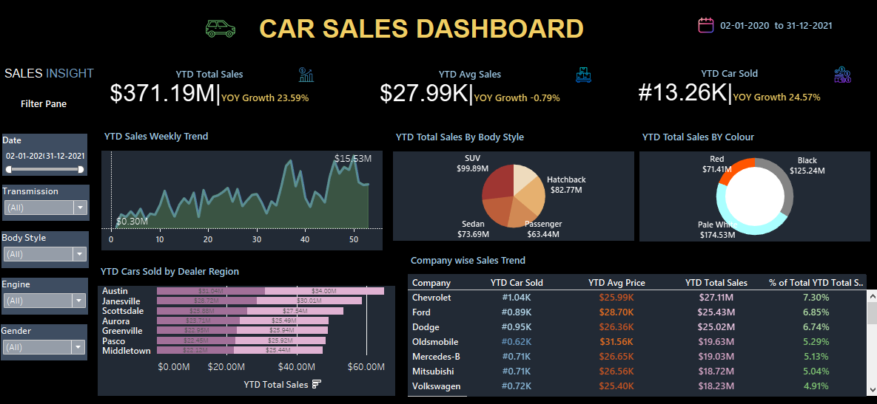

Project Overview

This Car Sales Dashboard analyzes car sales data between February 1, 2020, and December 31, 2021.  
It provides meaningful insights into total sales, average sales, car types, colors, regional performance, and company-wise sales to support better business decisions.

Key Insights

* YTD Total Sales:  
  ➔ $371.19 Million  
  ➔ Year-over-Year (YOY) Growth: +23.59%
* YTD Average Sale Price:  
  ➔ $27.99 Thousand  
  ➔ YOY Growth: -0.79%
* YTD Cars Sold:  
  ➔ 13.26 Thousand Units  
  ➔ YOY Growth: +24.57%
* Weekly Sales Trend:  
  ➔ Sales peaked at $15.53 Million around Week 35 and Week 50.

Sales by Body Style

* SUV: $99.89M
* Hatchback: $82.77M
* Sedan: $73.69M
* Passenger: $63.44M

Sales by Color

* Pale White: $174.53M
* Black: $125.24M
* Red: $71.41M

Top Dealer Regions

* Austin: $34.00M
* Janesville: $30.00M
* Scottsdale: $25.45M

Top Companies

* Chevrolet:  
  ➔ 1.04K Cars Sold | $27.11M Sales | 7.30% Market Share
* Ford:  
  ➔ 0.89K Cars Sold | $25.43M Sales | 6.85% Market Share
* Dodge:  
  ➔ 0.95K Cars Sold | $26.36M Sales | 6.56% Market Share

Filters Used in Dashboard

* Date
* Transmission Type
* Body Style
* Engine Type
* Customer Gender

Visualizations Used

* Area Chart: Weekly Sales Trend
* Pie Chart: YTD Total Sales by Body Style
* Donut Chart: YTD Total Sales by Color
* Bar Chart: YTD Cars Sold by Dealer Region
* Tabular Grid: Company-wise Sales Trend

Conclusion

The Car Sales Dashboard provides a clear and detailed view of sales performance across different car body styles, colors, dealer regions, and companies.

By analyzing data from February 2020 to December 2021, the dashboard helps identify key trends, such as rising car sales, popular body styles like SUVs, and high-performing colors like Pale White.

It also highlights the strongest dealer regions and top-performing companies, giving businesses valuable insights for decision-making.

Using interactive filters and easy-to-understand visualizations, the dashboard supports better business planning, inventory management, marketing strategies, and forecasting future sales trends.

Overall, this dashboard is an essential tool for car manufacturers, dealerships, and managers who want to make data-driven decisions and stay competitive in the automotive market.